How to Jump-Start a Car Battery
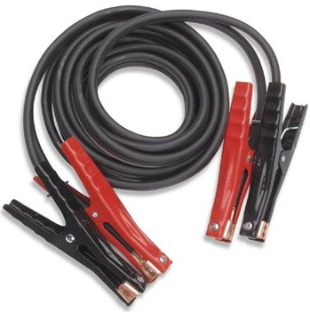
How to Jump-Start a Car Battery
A car battery. One of the most important car parts. And one that seems to die right when you need it the most: driving to your grandparent’s house for Christmas or some other inopportune time, usually in the winter (thanks, Murphy!) Here are some straightforward and easy tips for jump starting a car battery.
Things You'll Need:
* Jumper cables
* A car with a dead battery
* Another working car
* Protective eye gear
* Gloves

To jump-start a dead battery, you need another car that’s running normally and two jumper cables that have at least 6-gauge wires and are 12–18 feet long. Be very careful and always wear eye protection: a battery can explode if jump-started improperly.

- Read the owner’s manual for each car to make sure both can be involved in a jump-start. Electric ignitions, for example, can cause damage during jump-starts.
- Pull the two cars next to each other so that the batteries are close enough together for the jumper cables to reach. Do not allow the cars to touch.
- Shut off both cars. Make sure to turn off all accessories, such as lights, radios, and air conditioning. Remove all electrical devices, such as cell phones, from the car.
- Open the hoods of both cars. Make sure none of the cable clamps touch each other. The cables should not dangle into either car’s engine well, where they could get caught in moving parts.
- Connect the cables in the following order:
Connect one end of the positive (red) cable to the positive (+) terminal on the battery of the dead car.
Connect the other end of the positive (red) cable to the positive (+) terminal on the battery of the car that’s working (the booster car).
Connect one end of the negative (black) cable to the negative (–) terminal on the booster battery.
Connect the other end of the negative (black) cable to a clean, unpainted metal surface (such as the engine block) on the engine of the disabled vehicle. Try to find a spot on the engine far from the battery, as this connection might cause some sparks.
- Check once more that the booster cables are not near any moving parts.
- Start the booster car. Let it idle for 3–5 minutes.
- Try to start the car with the dead battery. If it won’t start, wait five minutes and try again. If it still won’t start, check to see if there are other problems, such as a lack of fuel. Do not keep trying to start the dead car, as you might cause additional damage.
- Once the dead car does start, remove the jumper cables in the reverse order in which you attached them in step 5. Do not let the cables fall into the engine or allow any part of the cables to touch.
- Keep the newly jump-started car running for at least 30 minutes to make sure the battery recharges fully. It may also be a good idea to take the car to a service station to get the battery thoroughly checked or replaced.
